E-Money Institution (EMI)
# Source: AI Source: Provided by: [Data Path: Persons Table -> ID Column: 1, Name_En Column: Motasem Essam] -> From: [ChatGPT] on [1/21/2026]
An E-Money Institution (EMI) is a licensed entity that issues, stores, and transfers electronic money — a digital alternative to physical cash. EMIs play a crucial role in modern payment systems by enabling wallet services, online transfers, and prepaid payment solutions without being a traditional bank.

🧠 Simple Definition
# Source: AI Source: Provided by: [Data Path: Persons Table -> ID Column: 1, Name_En Column: Motasem Essam] -> From: [ChatGPT] on [1/21/2026]
An E-Money Institution is a non-bank financial entity that is authorized to issue and manage electronic money, allowing users to make payments, transfers, and store value digitally.

💼 What is Electronic Money (E-Money)?
# Source: AI Source: Provided by: [Data Path: Persons Table -> ID Column: 1, Name_En Column: Motasem Essam] -> From: [ChatGPT] on [1/21/2026]
- Digitally stored value that represents fiat currency (e.g., $100 e-money = $100 cash equivalent)
- Stored on mobile wallets, cards, or online accounts
- Used for peer-to-peer transfers, bill payments, in-store & online purchases

🎯 Key Roles of an E-Money Institution
# Source: AI Source: Provided by: [Data Path: Persons Table -> ID Column: 1, Name_En Column: Motasem Essam] -> From: [ChatGPT] on [1/21/2026]
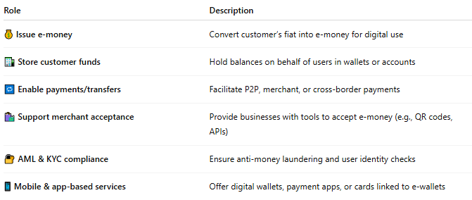

Role | Description
💰 Issue e-money | Convert customer’s fiat into e-money for digital use
🏦 Store customer funds | Hold balances on behalf of users in wallets or accounts
🔁 Enable payments/transfers | Facilitate P2P, merchant, or cross-border payments
🛍️ Support merchant acceptance | Provide businesses with tools to accept e-money (e.g., QR codes, APIs)
🔐 AML & KYC compliance | Ensure anti-money laundering and user identity checks
📱 Mobile & app-based services | Offer digital wallets, payment apps, or cards linked to e-wallets

🌐 Examples of E-Money Institutions
# Source: AI Source: Provided by: [Data Path: Persons Table -> ID Column: 1, Name_En Column: Motasem Essam] -> From: [ChatGPT] on [1/21/2026]
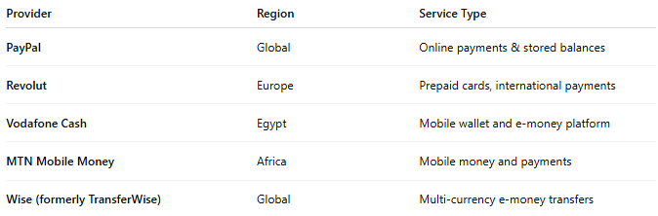

Provider | Region | Service Type
PayPal | Global | Online payments & stored balances
Revolut | Europe | Prepaid cards, international payments
Vodafone Cash | Egypt | Mobile wallet and e-money platform
MTN Mobile Money | Africa | Mobile money and payments
Wise (formerly TransferWise) | Global | Multi-currency e-money transfers
These are regulated under national or regional frameworks (e.g., EU E-Money Directive, Central Bank of Egypt licensing).

🔄 How EMIs Fit in the Payment System
# Source: AI Source: Provided by: [Data Path: Persons Table -> ID Column: 1, Name_En Column: Motasem Essam] -> From: [ChatGPT] on [1/21/2026]
- User deposits money into an e-wallet via bank transfer, card, or cash agent.
- EMI issues equivalent e-money in the wallet.
- User can:
  - Transfer funds to another user
  - Pay bills or buy online
  - Withdraw funds to a bank or cash point
- EMI manages float accounts (bank accounts holding the real money backing e-money)

🔐 Regulatory Requirements for EMIs
# Source: AI Source: Provided by: [Data Path: Persons Table -> ID Column: 1, Name_En Column: Motasem Essam] -> From: [ChatGPT] on [1/21/2026]
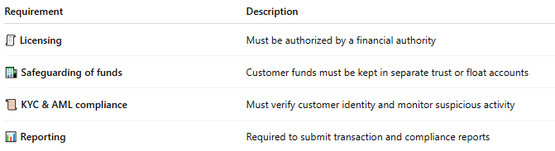

Requirement | Description
🧾 Licensing | Must be authorized by a financial authority
🏦 Safeguarding of funds | Customer funds must be kept in separate trust or float accounts
📜 KYC & AML compliance | Must verify customer identity and monitor suspicious activity
📊 Reporting | Required to submit transaction and compliance reports

✅ Benefits of E-Money Institutions
# Source: AI Source: Provided by: [Data Path: Persons Table -> ID Column: 1, Name_En Column: Motasem Essam] -> From: [ChatGPT] on [1/21/2026]
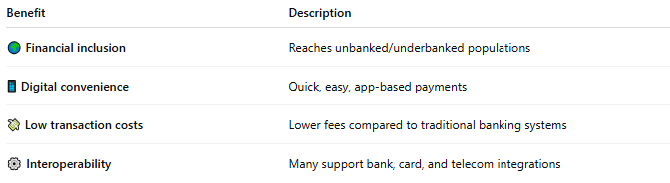

Benefit | Description
🌍 Financial inclusion | Reaches unbanked/underbanked populations
📱 Digital convenience | Quick, easy, app-based payments
💸 Low transaction costs | Lower fees compared to traditional banking systems
⚙️ Interoperability | Many support bank, card, and telecom integrations

🧠 Summary
# Source: AI Source: Provided by: [Data Path: Persons Table -> ID Column: 1, Name_En Column: Motasem Essam] -> From: [ChatGPT] on [1/21/2026]
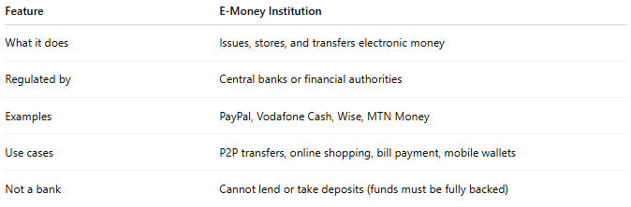

Feature | E-Money Institution
What it does | Issues, stores, and transfers electronic money
Regulated by | Central banks or financial authorities
Examples | PayPal, Vodafone Cash, Wise, MTN Money
Use cases | P2P transfers, online shopping, bill payment, mobile wallets
Not a bank | Cannot lend or take deposits (funds must be fully backed)

